CZ1106 Tutorial TWO

Addressing Modes, Assembly Programming

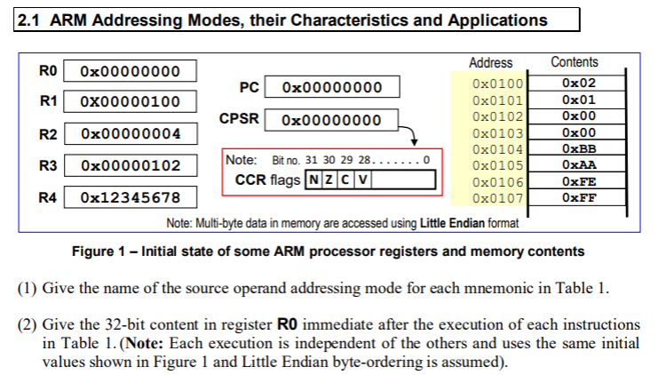



|  |  |  |  |
| --- | --- | --- | --- |
| No | Mnemonics | Source addressing mode | Content in R0 |
| 1 | MOV R0, R2 | Register direct ✅ | 0x0000 0004 |
| 2 | MOV R0, #0x100 | Immediate value ✅ | 0x1000 0000 |
| 3 | LDR R0, [R1] | Register indirect ✅ | 0x0000 0102 |
| 4 | LDR R0, [R1, #4] | Register indirect with offset ❌ base + offset (pre-index) | 0xFFFE AABB |
| 5 | LDR R0, [R1, R2] | Register indirect with index register ❌ base + index register (pre-index) | 0xFFEE AABB |
| 6 | LDR R0, [R1, #4]! | Register indirect with immediate value pre-autoindexing ✅ | 0xFFEE AABB |
| 7 | LDR R0, [R1], #4 | Register indirect with immediate value post-autoindexing ✅ | 0x0000 0102 |
| 8 | LDR R0, [R1, R2]! | Register indirect with index register pre-autoindexing ✅ | 0xFFFE AABB |
| 9 | LDR R0, [R1], R2 | Register indirect with index register post-autoindexing ✅ | 0x0000 0102 |

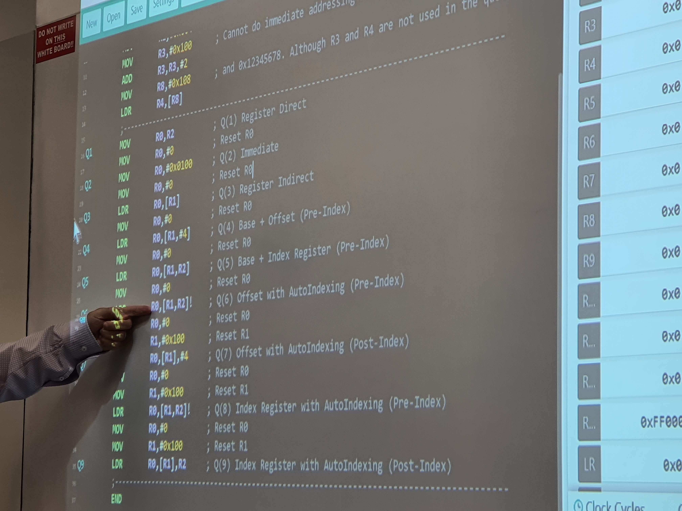

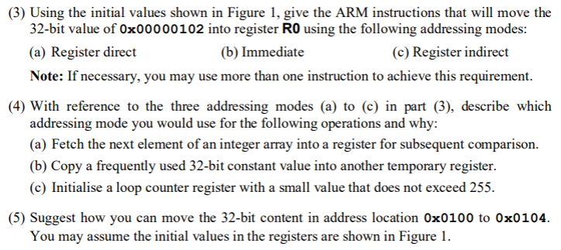

a) MOV R0, R3 ✅

b)

MOV R0, #0x100

ADD R0, R0, #2 ✅

c) MOV R0, [R1] ❌LDR R0, [R1]



a) Register indirect

b) Register direct

c) Immediate



32-bit = 4 bytes = one memory address

MOV R0, #0x0100

MOV R1, #0x104

LDR R2, [R0]

STR R2, [R1]

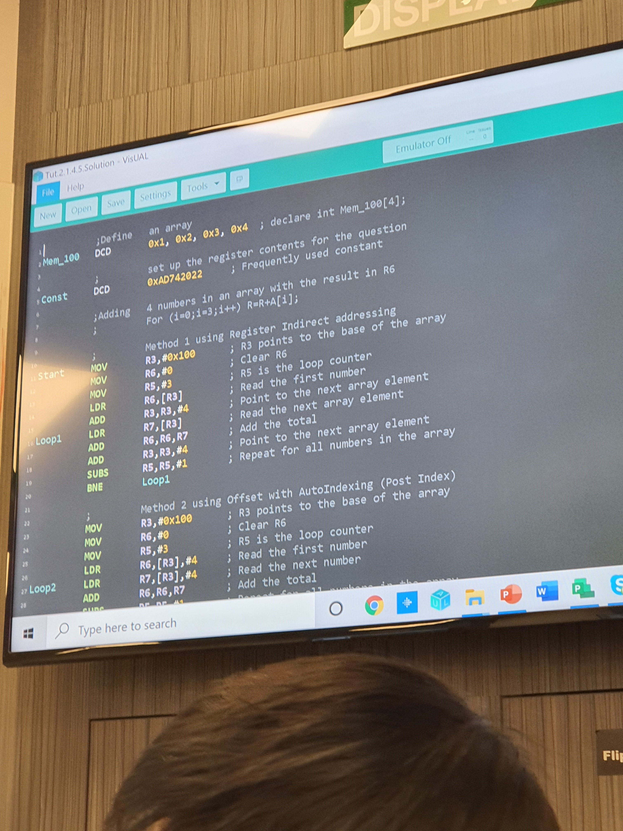

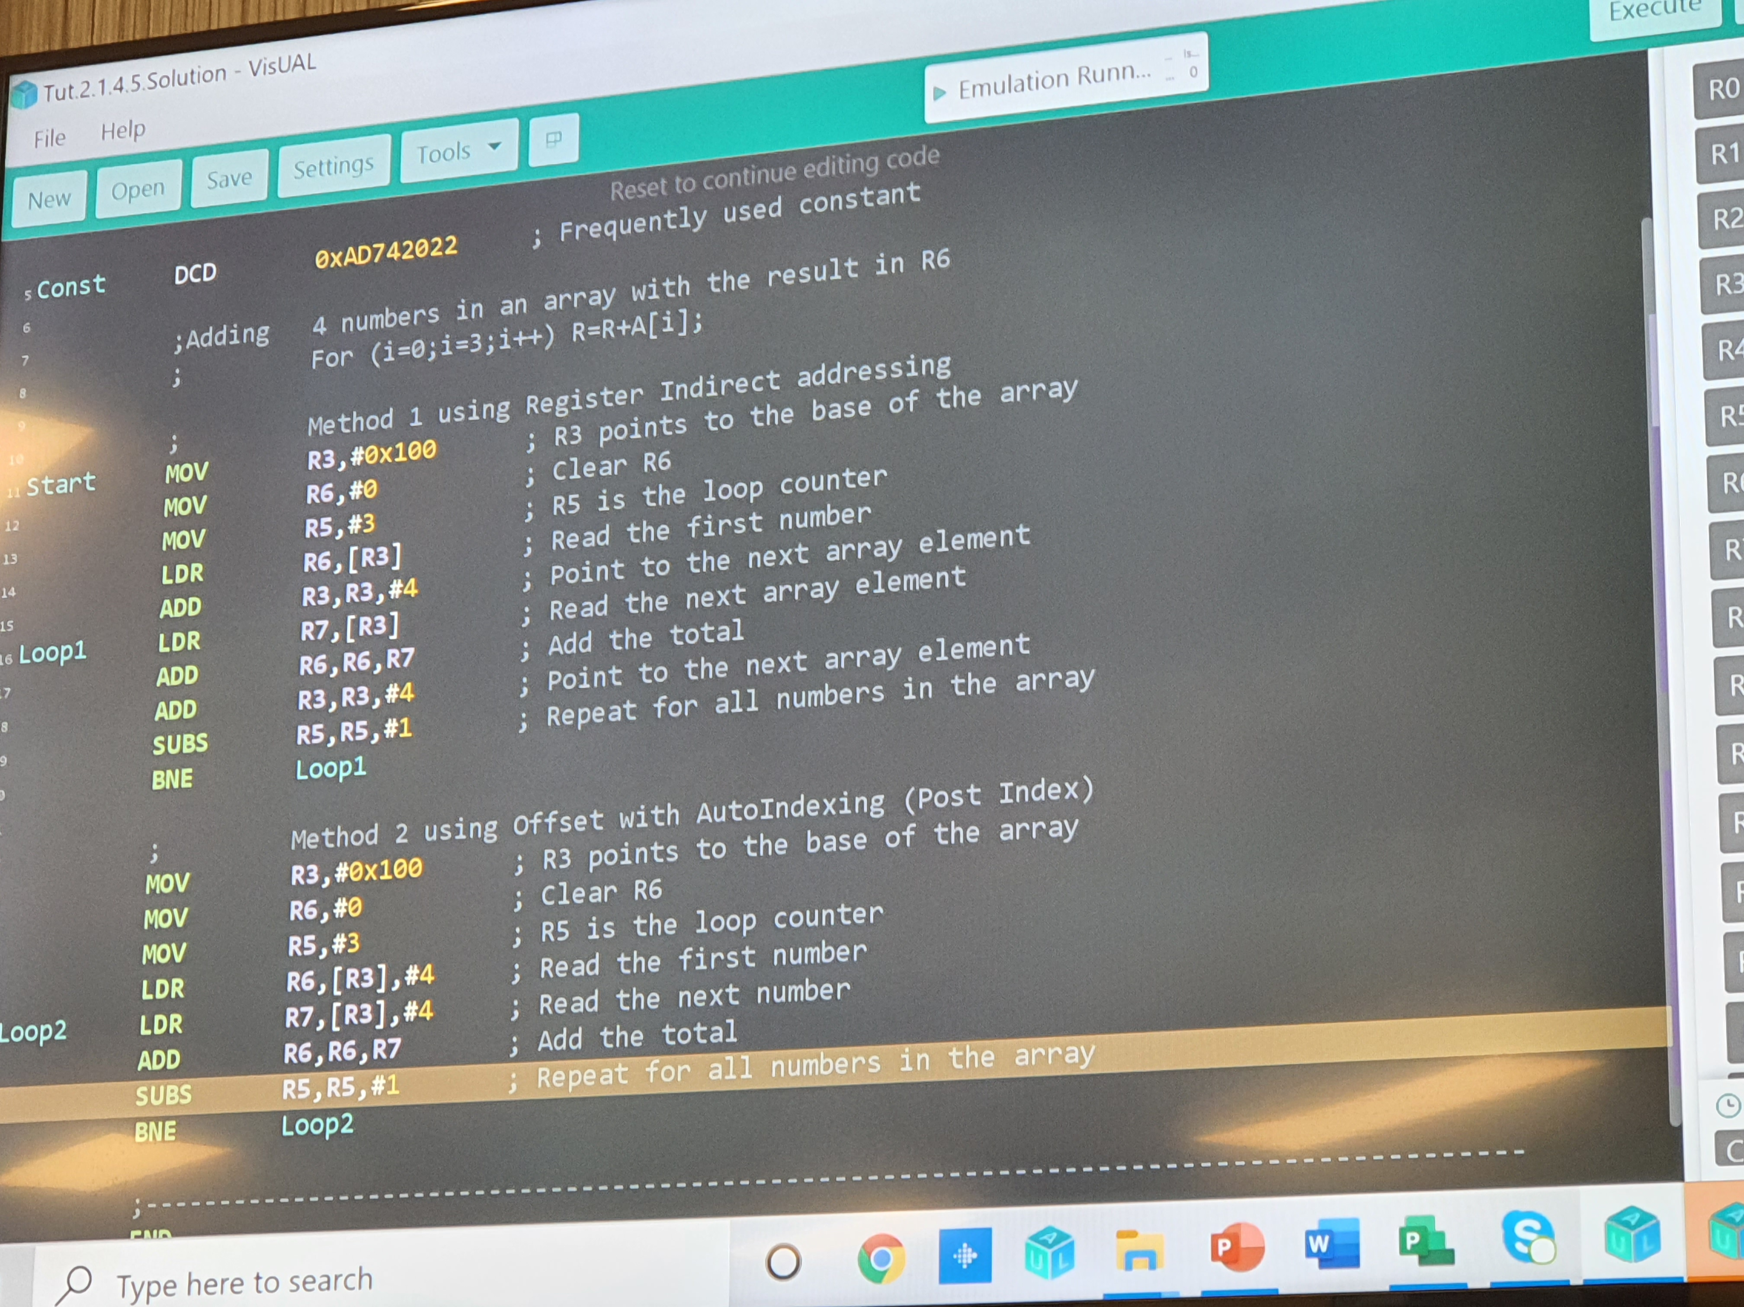

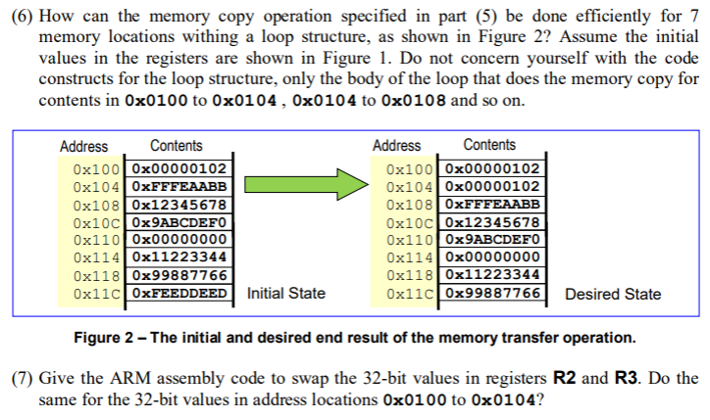

MOV R0, #0x11C

MOV R2, #7

loop LDR R1, [R0, #-4]!

STR R1, [R0, #4]

SUBS R2, R2, #1

BNE loop



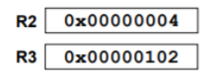

MOV R1, R2

MOV R2, R3

MOV R3, R1

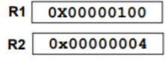

MOV R1, #0x100

MOV R2, #0x4

LDR R3, [R1]

LDR R4, [R1, R2]

STR R3, [R1, R2]

STR R4, [R1]

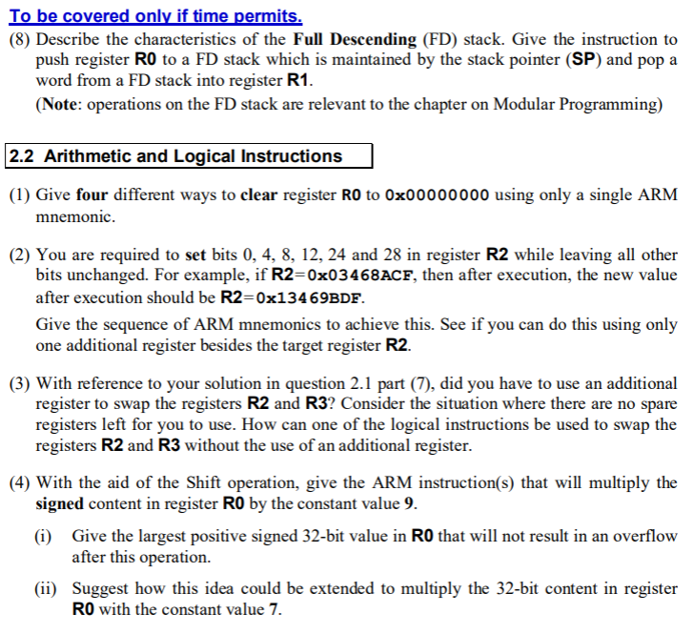

Grows towards lower memory level. Pointer points to an existing element in the stack.

Push:

MOV R2, SP

STR R0, [R2, #-4] ❌need the !

Pop:

LDR R0, [SP], #4 ✅



SUB R0, R0, R0 ✅

MOV R0, #0x0 ✅

AND R0, R0, #0 ✅

MVN R0, #0xFFF ❌EOR R0, R0, R0



MOV R2, #0

MOV R6, #6

MOV R0, #0x0001

loop ORR R2, R2, R0

LSL R0, R0, #4

SUBS R6, R6, #1

BNE loop

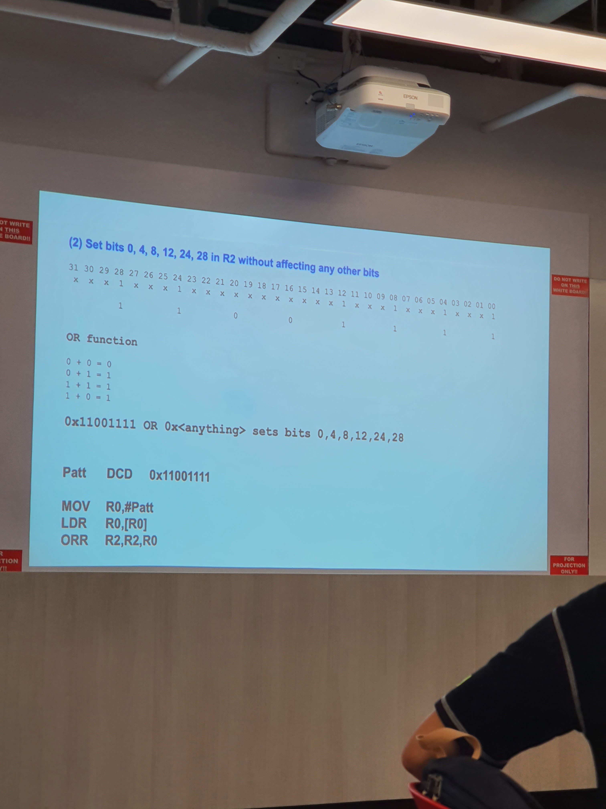



Yes.

??????????????????????????



????????????????????????????

i) 0x7FFF FFFF is the largest value after operation. Divide by 9 --> ????????

ii) ?????????????

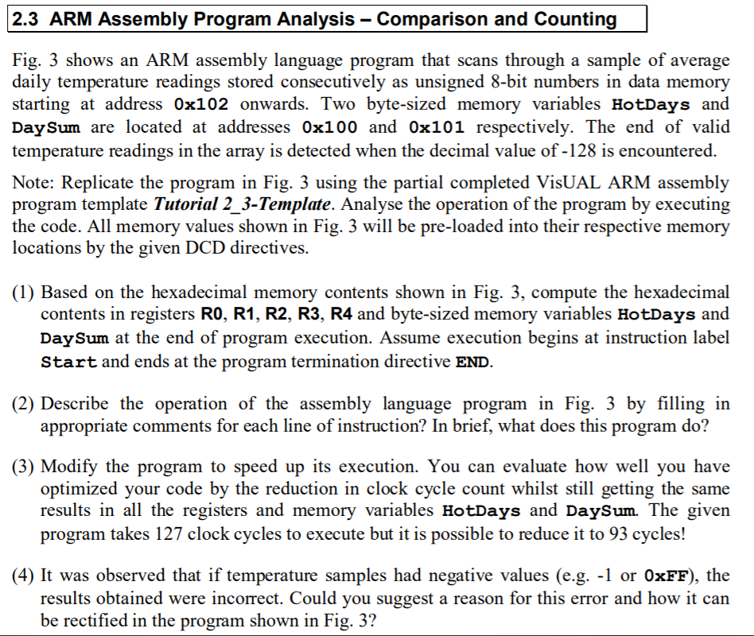

R0 is the number of days, i.e. 7 (since 0x80 indicates the end of the array)

R1 is the memory index of the last element in the array, i.e. 0x109

R2 counts the number of elements more than or equal to 36, which is 3 (0x24, 0x32, 0x28)

R3 retrieves the elements from the array, i.e. 0x80

R4 ends at 0x101



Loops through each element to: count total number of days in R0 and number of days where temperature exceeds 36 in R2.



Remove the second LDRB.

Use auto-indexing to add to R1 instead of the ADD operation.



BHS was used, which is unsigned. 0xFF is hence interpreted as 255 when it is actually –1 in signed value representation. Use GT.

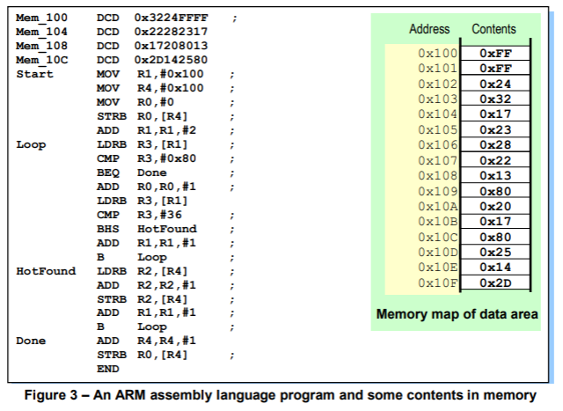

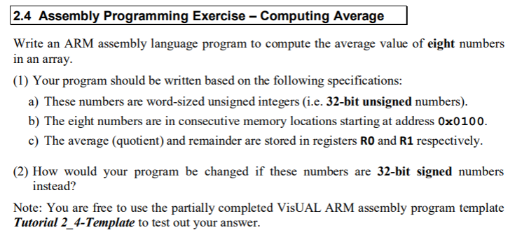

MOV R0, #0

MOV R1, #0x100

MOV R2, #8

SUBS R2, R2, #1❌should be in loop

BNE loop ❌should be in loop

loop LDR R3, [R1], #1❌#4 not #1 – data is 32-bit!!

ADD R0, R0, R3

MOV R0, R0 LSR #3 ✅

0. Set loop counter. MOV R2, #8

1. Clear cumulative register R0 to zero. MOV R0, #0

2. Point to start of array. MOV R1, #0x100

3. loop

3.1 Use register indirect with post-index to fetch elements. LDR R3, [R1], #4

3.2 ADD R0, R0, R3

3.3 SUBS R2, R2, #1

3.4 BNE loop

**Remainder after diving by 8 is the 3 LSBs!! (because they are less than 8)**

MOV R1, R0

AND R1, R1, #7 ;clear all bits except the 3 LSB

MOV R0, R0, LSR #3



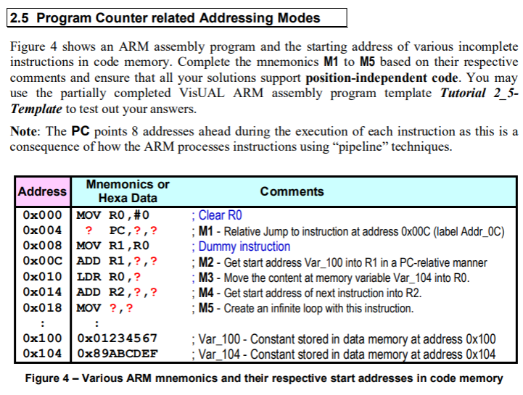

ADD PC, PC, #0. ✅MOV PC, PC works also

Address of Var_100 = 0x100 – 0x00C – 0x008 = 0x100 – 0x014 = 0x0FF + 0x001 – 0x014 = 0x0EC

ADD R1, PC, #0x0EC ✅need the PC as the reference.

0x104 – 0x010 – 0x008 = 0x0D2

LDR R0, [PC, #0x0D2] ❌LDR R0, [R1, #4]

ADD R2, PC, #-4 ✅

MOV PC, #0x010❌#0x018. MOV PC, R2 since R2 contains #0x018.